CMMI Kolkata Chapter Monthly Virtual Lecture Meeting held on Friday, 29th May 2020, In Zoom
The Kolkata Chapter of The Company of Master Mariners of India held its monthly virtual lecture meeting on the evening of Friday, 29 May 2020 in Zoom.
In his opening speech, the Chairman of the Kolkata Chapter, Capt. Kaustuv Dutta, welcomed the members present.
A lecture was presented on The future of Inspection Preparations - Reduce Observations, Stop detentions by Capt. Debashis Basu, 3329/ LM CMMI Member, VLCC master and Owner/Co-founder of Navguide Solutions LLP,. A company which develops maritime software solutions.

Guide2Inspections™: The Future of Ship Preparations

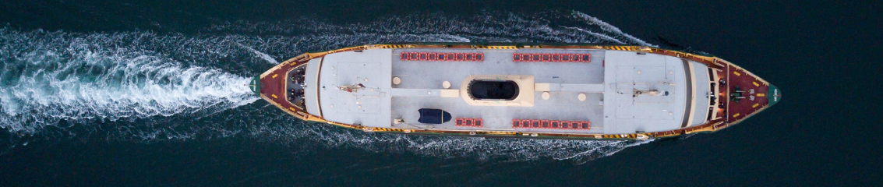
“Too Many regulations!!”
“Too much stress on the job!!”
“What on earth are we doing preparing for inspections all the time?”
Isn’t this the most common coffee-time-discussions on board?
Inspections are important and they make ships safer, but they also take a lot of time away from us. There is simply too much to cover and things are not getting any simpler. This thought led to a systematic process called Guide2Inspections™, which effectively improves ship-preparation for any inspection and keeps the vessel inspection ready and compliant at all times with minimal shore interference.
Guide2Inspections™ is a proprietary process developed by Navguide Solutions, a company founded by Capt. Debashis Basu, and it offers an approach not seen earlier in this industry. Capt. Basu, a VLCC Master, entrepreneur and CMMI Member since 2018, has spent over three years to integrate modern teaching tools and methods, including simulation games and videos, which can change the way we look at preparing a ship.
Interesting and ambitious, isn’t it? Here are a few things you may find engaging.
They are replacing checklists!
They created short guidance videos covering various locations onboard. This can effectively replace checklists in the long run, with several added advantages. Think about this, when you want to inspect a certain area, instead of carrying a detailed checklist, watch a 3 to 5-minute video and then head out to inspect. The video will audiovisually guide you into not only what to check, but also how to, and reduce your inspection time.

YouTube has shown us that we can learn faster through videos than any written format, and it’s especially useful to empower the young millennial seafarers in a way that they understand. This is also the World's First Virtual Tour guide for vessel inspections.

They did a ton of research
Creation of Guide2Inspections™ has been a thorough process. It took them a study of various regulations, company guidances, and more than 35,000 observations from SIRE, PSC, USCG inspection-results over several years. They pooled in the experience of senior auditors and inspectors to bring in the practical eye as well.
It gave them something robust which would not miss out much.
They can reduce preparation time!
They systematically divided the checks time-wise. Few things to be checked once and for all, few to be checked prior-arrival and some on arrival. Such a systematic division does not force you to inspect every item before each inspection and reduces preparation time, while still covering every aspect in detail.
Trust the process. And BAM! Just like that, your ship remains Inspection-ready!
Hitting the right nerve with the young generation!
One essential element to train our millennial seafarers is to generate interest in them. With so many options in life, any learning method which becomes boring is never going to work. We mentioned the videos before, but there are also other tools up their sleeve.

They have Interactive simulation games which can simulate a real conversation during an inspection. It also affects the behavioural aspects of a seafarer. Attitude development is a highly underrated concept but extremely impactful in the real world.

A remote-inspection tool
Guide2Inspections™ can also be used by inspectors and auditors as a tool for remote or physical inspections. As a remote inspection tool, their e-checklist guides the seafarers into what to see and verify, how to report back with photos, videos, attachments, set their target dates and generate reports in the shortest possible time.
Most importantly, all of this can be implemented remotely without setting foot on the ship.
Conclusion
The focus may be on inspections, but the process impacts many other aspects of the vessel. Overall, Guide2Inspections seemed to be serving the need of the hour and is also meant to stay on and affect the seafaring world for some time to come.
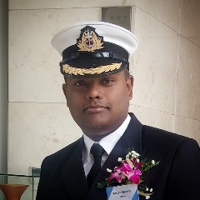
Captain Debashis Basu
Creator of Guide2inspections, entrepreneur, VLCC Master, CMMI Member.
Email: captain@thenavigatorsguide.com
Website: https://inspections.thenavigatorsguide.com/

The house thanked Capt. Debashis Basu for the valuable presentation which was lucid, rich in content and well researched.
The virtual meeting was conducted live in Zoom and was also telecast live in Face book page of CMMI, TV app, Website and You Tube channel of Sailor Today.
The virtual meeting was attended by over 250 members worldwide.
Sailor Today did a commendable job for the live telecast in various digital platforms.

